Bahria University,

Karachi Campus



LAB EXPERIMENT NO.

**2**

LIST OF TASKS

|  |  |
| --- | --- |
| TASK NO | OBJECTIVE |
| **1** | Write a Python program that calculates the absolute as well as relative error present in the following measurements:  **Actual values:** [11.0098, 167.902, 56.0567, 67.9860] **Measured values:** [12.0001, 166.802, 55.0001, 69.0000] |
| **2** | Write a Python program that calculates the square root of following numbers using both the math.sqrt function (which uses floating-point arithmetic) and a custom square root function that uses integer arithmetic. Then, find and compare the results to observe the rounding error.  **(56.90, 100.45, 67.90, 25.67, 56.67)** |
| 3 | Write a Python program which finds the value of PI (π) using Taylor series, and then find the truncating error occurred due to the use of a finite number of terms. |

Submitted On:

____________

8 October 2024

(Date: DD/MM/YY)

**Task 1**

**Write a Python program that calculates the absolute as well as relative error present in the following measurements:**

**Actual values: [11.0098, 167.902, 56.0567, 67.9860]  
Measured values: [12.0001, 166.802, 55.0001, 69.0000]**

**Solution:**

num_terms = 1000

true_pi = 3.141592653589793

def calculate_pi(terms):

    pi_over_4 = 0

    for n in range(terms):

        pi_over_4 += ((-1) ** n) / (2 * n + 1)

    return pi_over_4 * 4

def calculate_truncation_error(true_value, estimated_value):

    return abs(true_value - estimated_value)

num_terms = 1000

true_pi = 3.141592653589793

estimated_pi = calculate_pi(num_terms)

error = calculate_truncation_error(true_pi, estimated_pi)

print(f"Estimated value of p: {estimated_pi}")

print(f"Truncation error: {error}")

act = [11.0098,167.902, 56.0567, 67.9860]

mes = [12.0001,166.802, 55.0001, 69.0000]

for i in range(len(act)):

        error = abs(act[i]- mes[i])

        relative = error / abs(act[i]) * 100

        print("Absolute error",i,": ",error)

        print("Relative error",i,": ",relative)

        print("------------------------------")

**Output:**

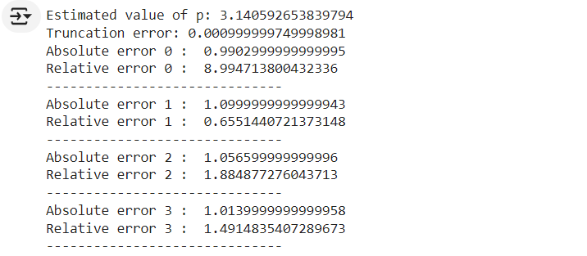

**Task 2**

**Write a Python program that calculates the square root of following numbers using both the math.sqrt function (which uses floating-point arithmetic) and a custom square root function that uses integer arithmetic. Then, find and compare the results to observe the rounding error.**

**(56.90, 100.45, 67.90, 25.67, 56.67)**

**Solution:**

import math

def int_sqrt(n):

    if n < 0:

        raise ValueError("Cannot compute square root of negative number")

    guess = n // 2

    better_guess = (guess + n // guess) // 2

    while better_guess < guess:

        guess = better_guess

        better_guess = (guess + n // guess) // 2

    return guess

numbers = [56.90, 100.45, 67.90, 25.67, 56.67]

print(f"{'Number':>10} {'math.sqrt':>15} {'Custom sqrt':>15} {'Rounding Error':>15}")

for num in numbers:

    math_sqrt_result = math.sqrt(num)

    custom_sqrt_result = int_sqrt(int(num))

    rounding_error = math_sqrt_result - custom_sqrt_result

    print(f"{num:>10} {math_sqrt_result:>15.8f} {custom_sqrt_result:>15} {rounding_error:>15.8f}")

**Output:**

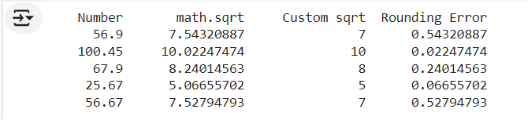

**Task 3**

**Write a Python program which finds the value of PI (π) using Taylor series, and then find the truncating error occurred due to the use of a finite number of terms.**

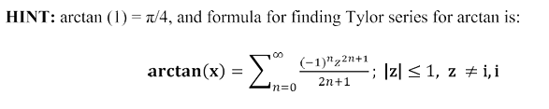

**Solution:**

import math

# Taylor series for arctan(x)

def arctan_taylor(x, terms):

    result = 0.0

    for n in range(terms):

        term = ((-1) ** n) * (x ** (2 * n + 1)) / (2 * n + 1)

        result += term

    return result

# Function to calculate pi using arctan(1) = pi/4

def calculate_pi(terms):

    arctan_value = arctan_taylor(1, terms)

    pi_value = 4 * arctan_value

    return pi_value

# Truncation error for pi approximation

def truncation_error(approx_pi):

    true_pi = math.pi

    return abs(true_pi - approx_pi)

# Number of terms in the Taylor series

terms = 10  # You can change this to increase precision

# Calculating pi and the truncation error

approx_pi = calculate_pi(terms)

error = truncation_error(approx_pi)

print(f"Calculated Pi using {terms} terms: {approx_pi:.10f}")

print(f"True Pi value: {math.pi:.10f}")

print(f"Truncation error: {error:.10f}")

**Output:**

